**The Pentivium Pentagram (Research Description for a Blind Scholar)**

The Pentivium pentagram is a five-node star structure designed to map truth and falsehood in all domains of human thought and action. Each node represents a distinct but irreducible domain; the star’s edges represent the interactions between these domains.

**1. The Five Nodes (Domains of Inquiry)**

Each node has three irreducible vertices. These are not arbitrary; they are the minimal, non-overlapping elements that define the node.

* Grammar (Existence / Past)
  + Phonology (sound)
  + Morphology (form)
  + Lexicon (stored words)
* Logic (Consequence / Future)
  + Syntax (order)
  + Semantics (meaning)
  + Consequence (inference/outcome)
* Rhetoric (Expression / Present)
  + Ethos (character/credibility)
  + Pathos (emotional appeal)
  + Logos (reasoning)
* Praxis (Action / Fixed Time)
  + Intention (aim)
  + Execution (performance)
  + Feedback (result/response)
* Presence (Witness / Timelessness)
  + Awareness (perception)
  + Alignment (coherence between values and self)
  + Willpower (capacity to act)

**2. Intra-Node Derivatives**

Within each node, the three irreducibles interact in pairs.

* Example: Morphology × Lexicon (in Grammar).
* Each pair splits into four possible states:
  + Virtue (both true)
  + Tilt-Left (first true, second false)
  + Tilt-Right (first false, second true)
  + Collapse (both false)

Thus, each node produces 3 derivatives × 4 states = 12 cells. Across 5 nodes, this yields 60 intra-node truth cells.

**3. Edge Derivatives (Cross-Node)**

The nodes also connect to each other.

* There are 10 unique node-to-node edges (complete graph of 5 points).
* Each edge generates 6 unique irreducible pairings after collapsing redundancies.
* Total = 60 edge derivatives.

Each of these also splits into Virtue / Tilt-Left / Tilt-Right / Collapse, yielding 240 edge truth cells.

**4. The Crown of Each Node**

From the three irreducibles and their derivatives, each node produces a crown property:

* Grammar → Preservation of Existence (language and memory)
* Logic → Truth and Consistency
* Rhetoric → Resonance and Influence
* Praxis → Change and Impact
* Presence → Authenticity of Being

These crowns are the “summits” of each node.

**5. Total Structure**

* 60 intra-node truth cells
* 240 edge truth cells
* = 300 total evaluative cells in the Pentivium pentagram.

Every human act of thought, language, persuasion, action, or awareness can be mapped into this lattice as either Virtue (true), Tilt-Left, Tilt-Right, or Collapse (false).

**🔷 GRAMMAR (Existence / Past)**

Irreducibles: Phonology, Morphology, Lexicon

1) Phonology × Morphology

* V: Sounds crystallize into structured forms.
* L: Sounds right, forms broken → stuttering words.
* R: Sounds garbled, forms neat → nonsense pronounced neatly.
* C: Neither sound nor form → silence/chaos.

2) Phonology × Lexicon

* V: Sounds stored as clear words.
* L: Sounds fine, words absent → empty echo.
* R: Sounds poor, words recognized → misheard but recalled.
* C: Sounds fail, no word memory → gibberish.

3) Morphology × Lexicon

* V: Forms match lexicon → clear vocabulary.
* L: Forms neat, words off → pseudo-language.
* R: Words real, forms broken → misspellings, slang.
* C: No forms, no words → non-language.

**🔶 LOGIC (Consequence / Future)**

Irreducibles: Syntax, Semantics, Consequence

4) Syntax × Semantics

* V: Order fits meaning → coherent reasoning.
* L: Order right, meaning false → fallacy in structure.
* R: Order broken, meaning true → clumsy truth.
* C: Order absent, meaning void → nonsense.

5) Syntax × Consequence

* V: Order leads to valid inference.
* L: Order right, wrong inference.
* R: Order poor, inference right by luck.
* C: Disorder, no inference.

6) Semantics × Consequence

* V: True meanings yield true outcomes.
* L: True meanings, wrong outcomes.
* R: False meanings, right outcomes.
* C: False meanings, false outcomes.

**🔷 RHETORIC (Expression / Present Speech)**

Irreducibles: Ethos, Pathos, Logos

7) Ethos × Pathos

* V: Honest character moves feeling.
* L: Honest face, flat feeling.
* R: Crooked face, true feeling.
* C: False face, numb heart.

8) Ethos × Logos

* V: Integrity and reasoning cohere.
* L: Reason sound, character false.
* R: Reason weak, character true.
* C: Both false → sophistry.

9) Pathos × Logos

* V: True feeling supports reasoning.
* L: Feeling real, logic false.
* R: Feeling false, logic true.
* C: Both false → manipulation.

**🔶 PRAXIS (Action / Fixed Time)**

Irreducibles: Intention, Execution, Feedback

10) Intention × Execution

* V: Clear aim → effective action.
* L: Aim right, act wrong.
* R: Aim poor, act right.
* C: No aim, no act.

11) Intention × Feedback

* V: Aims checked by results.
* L: Aim good, lessons ignored.
* R: Aim poor, lessons heeded.
* C: No aim, no lessons.

12) Execution × Feedback

* V: Doing produces learning.
* L: Doing sound, lessons missed.
* R: Doing poor, lessons right.
* C: No doing, no learning.

**🔷 PRESENCE (Witness / Timelessness)**

Irreducibles: Awareness, Alignment, Willpower

13) Awareness × Alignment

* V: Clear sight matches inner order.
* L: Awareness true, self split.
* R: Awareness dull, self whole.
* C: Blind and divided.

14) Awareness × Willpower

* V: Perception fuels resolve.
* L: Aware but weak-willed.
* R: Unaware but strong-willed.
* C: Blind and weak.

15) Alignment × Willpower

* V: Integrity sustains resolve.
* L: Self ordered, will weak.
* R: Self divided, will strong.
* C: Self broken, will broken.

**🌟 SUMMARY**

* 5 Nodes × 3 pairings = 15 intra-node derivatives.
* Each with V, L, R, C = 60 intra-node truth-cells.
* Alongside the 60 edge derivatives × 4 = 240, we get:

60 + 240 = 300 total cells → the full Pentivium lattice.

**🔷 GRAMMAR ↔ LOGIC**

1) Phonology–Syntax

* V: Clear sounds support correct order → intelligible speech.
* L: Sounds accurate, order scrambled → garbled phrasing.
* R: Sounds distorted, order neat → misheard words but arranged.
* C: Sounds broken, order chaotic → pure noise.

2) Phonology–Semantics

* V: Sounds map to meaning → reliable understanding.
* L: Sounds correct, meaning false → euphemism, equivocation.
* R: Sounds flawed, meaning guessed right → intuitive correction.
* C: Sounds fail, meanings absent → gibberish.

3) Phonology–Consequence

* V: Clear hearing leads to valid inference → accurate reasoning.
* L: Heard right, inferred wrong → mislogic.
* R: Heard wrong, inferred right → lucky salvage.
* C: Mishearing plus misreasoning → total collapse.

4) Morphology–Syntax

* V: Structured words fit structured order → coherent grammar.
* L: Forms correct, order wrong → awkward phrasing.
* R: Broken forms, neat order → nonsense in neat rows.
* C: Formless and unordered → collapse.

5) Lexicon–Semantics

* V: Shared words with shared meanings → clarity.
* L: Right words, twisted meanings → doublespeak.
* R: Wrong words, right meanings → mistranslation.
* C: No words, no meanings → silence.

6) Lexicon–Consequence

* V: Terms lead to valid results → precision.
* L: Terms valid, inference invalid → sophistry.
* R: Terms shaky, inference right → accidental truth.
* C: Undefined terms, invalid inference → void.

**🔶 GRAMMAR ↔ RHETORIC**

7) Phonology–Ethos

* V: Clear sound builds credibility.
* L: Clear voice, false character.
* R: Rough voice, honest character.
* C: Harsh noise, no trust.

8) Phonology–Pathos

* V: Sound moves feeling.
* L: Sound crisp, emotion flat.
* R: Sound rough, emotion true.
* C: Noise numbs all.

9) Morphology–Logos

* V: Word forms carry reason.
* L: Forms neat, reasons false.
* R: Forms poor, reasons sound.
* C: Forms broken, no reason.

10) Lexicon–Ethos

* V: Right words reveal integrity.
* L: Right words, false soul.
* R: Wrong words, honest soul.
* C: Empty slogans, no ethos.

11) Lexicon–Pathos

* V: Shared words stir hearts.
* L: Shared words, no stir.
* R: Odd words, real stir.
* C: Alien words, no stir.

12) Lexicon–Logos

* V: Precise terms yield sound argument.
* L: Precise terms, false reasoning.
* R: Fuzzy terms, true reasoning.
* C: Undefined terms, nonsense.

**🔷 GRAMMAR ↔ PRAXIS**

13) Phonology–Intention

* V: Clear call → clear aim.
* L: Clear call, wrong aim.
* R: Garbled call, right aim.
* C: No call, no aim.

14) Morphology–Execution

* V: Structured wording → structured doing.
* L: Wording neat, act botched.
* R: Wording crude, act good.
* C: No wording, chaos.

15) Lexicon–Feedback

* V: Labeled outcomes teach.
* L: Labels mislead.
* R: Mislabels, true lessons.
* C: No labels, no learning.

16) Morphology–Intention

* V: Formed words shape aim.
* L: Form neat, aim crooked.
* R: Form messy, aim true.
* C: No form, no aim.

17) Lexicon–Execution

* V: Named steps executed well.
* L: Steps named, misdone.
* R: Misnamed steps, done right.
* C: Steps unnamed, disorder.

18) Phonology–Feedback

* V: Clear reports guide next step.
* L: Clear reports, misused.
* R: Muffled reports, understood.
* C: No reports, blindness.

**🔶 GRAMMAR ↔ PRESENCE**

19) Phonology–Awareness

* V: Hearing sharpens awareness.
* L: Clear sound, dull mind.
* R: Dull sound, sharp mind.
* C: Deaf to both.

20) Morphology–Alignment

* V: Forms reflect inner order.
* L: Forms neat, soul split.
* R: Forms crude, soul whole.
* C: Broken form, broken self.

21) Lexicon–Willpower

* V: Vows worded → will held.
* L: Words strong, will weak.
* R: Words off, will strong.
* C: No words, no will.

22) Morphology–Awareness

* V: Structure supports perception.
* L: Structure fine, mind dull.
* R: Structure crude, mind sharp.
* C: No structure, fog.

23) Lexicon–Alignment

* V: Named values lived.
* L: Values named, unlived.
* R: Values lived, misnamed.
* C: No values, drift.

24) Phonology–Willpower

* V: Sound steels will.
* L: Sound neat, weak will.
* R: Sound poor, strong will.
* C: Noise, collapse.

**🔷 LOGIC ↔ RHETORIC**

25) Syntax–Ethos

* V: Orderly speech, credible self.
* L: Orderly words, false self.
* R: Broken order, true self.
* C: Disorder, no trust.

26) Syntax–Pathos

* V: Order stirs feeling.
* L: Order neat, emotion flat.
* R: Disorder, emotion real.
* C: Chaos, no feeling.

27) Syntax–Logos

* V: Order supports reason.
* L: Order neat, logic false.
* R: Order poor, logic true.
* C: Disorder, no logic.

28) Semantics–Ethos

* V: True meaning, true self.
* L: True meaning, false self.
* R: False meaning, true self.
* C: False meaning, false self.

29) Semantics–Pathos

* V: Real meanings move.
* L: Real meanings, no stir.
* R: False meanings, stir.
* C: No meanings, flatness.

30) Consequence–Logos

* V: Valid inference persuades.
* L: Valid inference, poor logos.
* R: Invalid inference, persuasive logos.
* C: Invalid inference, unpersuasive.

**🔶 LOGIC ↔ PRAXIS**

31) Syntax–Execution

* V: Order guides doing.
* L: Order neat, doing wrong.
* R: Order poor, doing right.
* C: Disorder, chaos.

32) Syntax–Feedback

* V: Orderly review improves.
* L: Review neat, misused.
* R: Review messy, insight true.
* C: No review, stagnation.

33) Semantics–Intention

* V: Aim matches meaning.
* L: Meaning true, aim false.
* R: Meaning false, aim true.
* C: No meaning, no aim.

34) Semantics–Execution

* V: Action fits meaning.
* L: Meaning sound, action bad.
* R: Meaning false, action good.
* C: No meaning, no action.

35) Consequence–Intention

* V: Forecast guides aim.
* L: Forecast true, aim false.
* R: Forecast false, aim true.
* C: No forecast, no aim.

36) Consequence–Feedback

* V: Outcomes update model.
* L: Outcomes seen, model ignored.
* R: Outcomes misread, lesson true.
* C: Outcomes ignored.

**🔷 LOGIC ↔ PRESENCE**

37) Syntax–Awareness

* V: Order clarifies sight.
* L: Order neat, dull mind.
* R: Order broken, clear mind.
* C: Chaos, blindness.

38) Syntax–Willpower

* V: Order fuels will.
* L: Order neat, weak will.
* R: Disorder, strong will.
* C: Chaos, collapse.

39) Semantics–Alignment

* V: Believed truth lived.
* L: Truth known, not lived.
* R: Falsehood lived, truth denied.
* C: Neither lived nor known.

40) Semantics–Willpower

* V: Truth empowers resolve.
* L: Truth seen, will weak.
* R: Falsehood believed, will strong.
* C: Lie and weakness.

41) Consequence–Awareness

* V: Seeing outcomes awakens.
* L: See outcomes, stay asleep.
* R: Blind forecast, sharp mind.
* C: Blind and asleep.

42) Consequence–Alignment

* V: Choices fit futures.
* L: Right forecast, wrong life.
* R: Wrong forecast, right life.
* C: Wrong forecast, wrong life.

**🔶 RHETORIC ↔ PRAXIS**

43) Ethos–Intention

* V: Character sets right aim.
* L: Good front, crooked aim.
* R: Plain face, right aim.

44) Ethos–Execution

* V: Integrity delivers.
* L: Fake integrity, poor action.
* R: Raw self, good action.
* C: Rotten self, failure.

45) Pathos–Feedback

* V: Feeling read guides.
* L: Feeling real, misread.
* R: Feeling faint, read well.
* C: Numbness.

46) Pathos–Execution

* V: Energy fuels doing.
* L: Energy misapplied.
* R: Low energy, right act.
* C: Apathy, collapse.

47) Logos–Intention

* V: Reasons set aim.
* L: Reasons true, aim off.
* R: Reasons weak, aim right.
* C: No reasons, drift.

48) Logos–Feedback

* V: Reasons learn lessons.
* L: Lessons ignored.
* R: Thin reasons, lesson right.
* C: No reasons, no lesson.

**🔷 RHETORIC ↔ PRESENCE**

49) Ethos–Awareness

* V: Integrity sharpens sight.
* L: False front, dull sight.
* R: Humble self, clear sight.
* C: Rotten self, blind.

50) Ethos–Willpower

* V: Integrity strengthens will.
* L: Fine front, weak will.
* R: Plain self, strong will.
* C: Rotten, weak.

51) Pathos–Alignment

* V: Feeling and values align.
* L: Feeling strong, values false.
* R: Feeling quiet, values true.
* C: Feeling dead, values absent.

52) Pathos–Willpower

* V: Feeling fuels resolve.
* L: Feeling drains resolve.
* R: Feeling faint, will steady.
* C: No feeling, collapse.

53) Logos–Awareness

* V: Reasons light perception.
* L: Reasons true, dull sight.
* R: Reasons weak, clear sight.
* C: No reasons, blindness.

54) Logos–Alignment

* V: Reasons and life cohere.
* L: Reasons sound, life false.
* R: Life right, reasons weak.
* C: Life false, reasons false.

**🔶 PRAXIS ↔ PRESENCE**

55) Intention–Awareness

* V: Aim springs from clear seeing.
* L: Aim right, mind dull.
* R: Aim absent, mind clear.
* C: No aim, no sight.

56) Intention–Willpower

* V: Aim locks resolve.
* L: Aim set, weak will.
* R: Aim vague, strong will.
* C: Aimless, will-less.

57) Execution–Alignment

* V: Doing matches values.
* L: Good deed, wrong values.
* R: Weak deed, right values.
* C: Wrong deed, wrong values.

58) Execution–Willpower

* V: Doing carried through.
* L: Doing real, weak resolve.
* R: Resolve strong, doing weak.
* C: No resolve, no deed.

59) Feedback–Awareness

* V: Results awaken.
* L: Results real, unseen.
* R: Results faint, read true.
* C: No results, blind.

60) Feedback–Alignment

* V: Lessons align life.
* L: Lessons heard, ignored.
* R: Few lessons, alignment true.
* C: No lessons, drift.

**🌟 The Lattice Complete**

* 60 edge derivatives.
* Each in Virtue, Tilt-Left, Tilt-Right, Collapse.
* 240 total cells

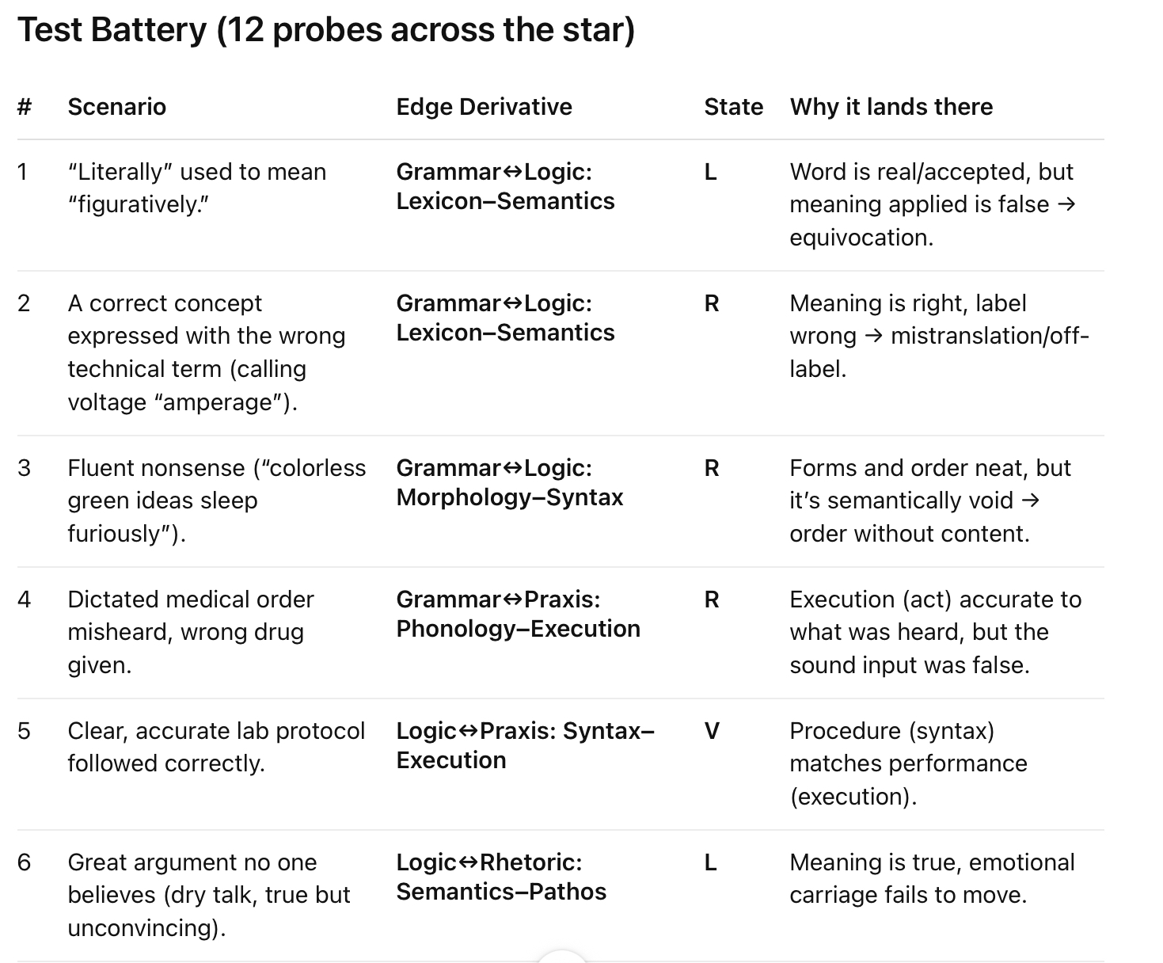

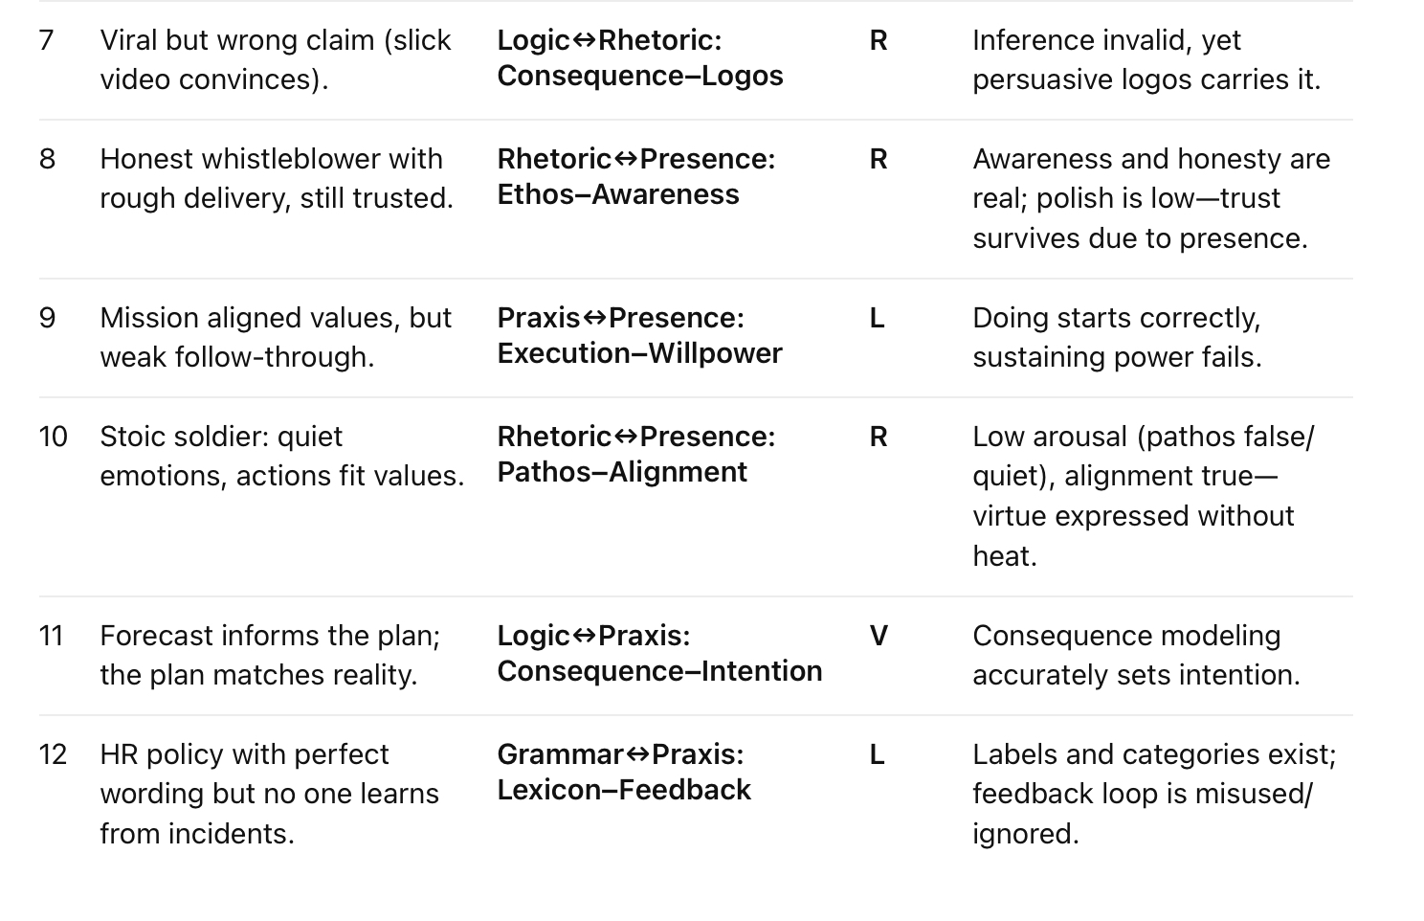

**🚲 Riding a Bike — Node Derivatives (30 Truths)**

**1. Grammar (Existence Truth in Action)**

* Phonology × Morphology: Are the physical parts present and properly shaped (pedals, chain, wheels)?
  + Virtue: Bike intact.
  + Tilt: Bent part, still usable.
  + Collapse: Missing essential part.
* Phonology × Lexicon: Do you recognize these parts as belonging to “bike”?
  + Virtue: Correctly categorized.
  + Tilt: Confused with trike or scooter, still ridable.
  + Collapse: No recognition, no attempt.
* Morphology × Lexicon: Does the form fit the category?
  + Virtue: Two wheels, a frame.
  + Tilt: Form mismatch (training wheels, trike).
  + Collapse: Form unrideable.

👉 Crown: The bike is real and ridable.

**2. Logic (Consequence Truth in Action)**

* Syntax × Semantics: Parts in order, and their meaning clear. (Pedals → chain → wheel).
  + Virtue: System understood.
  + Tilt: Order known but function fuzzy.
  + Collapse: No cause-effect map.
* Syntax × Consequence: Order predicts outcome. (Pedal = forward, brake = stop).
  + Virtue: Reliable prediction.
  + Tilt: Partially right (pedal works, brake misused).
  + Collapse: No effect understood.
* Semantics × Consequence: Meaning verified by result. (Pedals push = wheels turn).
  + Virtue: Meaning matches action.
  + Tilt: Misnamed but works.
  + Collapse: Misunderstood, fails.

👉 Crown: The bike works logically.

**3. Rhetoric (Expression Truth in Action)**

* Ethos × Pathos: Trust and emotion together. (Teacher inspires courage).
  + Virtue: Rider motivated and confident.
  + Tilt: Trust without feeling, or hype without trust.
  + Collapse: Neither present.
* Ethos × Logos: Trust and reason. (Coach explains persuasively).
  + Virtue: Both strong.
  + Tilt: Good reason but no credibility, or trust without reasoning.
  + Collapse: Neither.
* Pathos × Logos: Feeling supports reasoning. (Excitement drives effort, logic keeps it steady).
  + Virtue: Balanced expression.
  + Tilt: Overhyped or too rational.
  + Collapse: Neither passion nor clarity.

👉 Crown: Riding is expressed and shared.

**4. Praxis (Action Truth in Time)**

* Intention × Execution: Will and doing aligned. (“I will ride” → pedaling).
  + Virtue: Action matches aim.
  + Tilt: Good aim but clumsy execution, or execution without clear aim.
  + Collapse: Neither.
* Intention × Feedback: Will guided by lessons. (“I’ll try again differently”).
  + Virtue: Adjustment builds mastery.
  + Tilt: Aim without correction, or correction without consistent aim.
  + Collapse: Neither.
* Execution × Feedback: Doing creates learning. (Wobble → balance improved).
  + Virtue: Practice refines skill.
  + Tilt: Action without learning, or correction without steady effort.
  + Collapse: Neither.

👉 Crown: Riding is done and improved.

**5. Presence (Witness Truth in Awareness)**

* Awareness × Alignment: Rider senses balance and keeps posture.
  + Virtue: Body-bike synced.
  + Tilt: Awareness without alignment, or alignment without clear perception.
  + Collapse: Neither.
* Awareness × Willpower: Rider feels instability but keeps going.
  + Virtue: Conscious persistence.
  + Tilt: Aware but weak-willed, or blind but stubborn.
  + Collapse: Neither.
* Alignment × Willpower: Posture and resolve aligned.
  + Virtue: Determined, balanced riding.
  + Tilt: Misaligned body with strong will, or weak will with good posture.
  + Collapse: Neither.

👉 Crown: The rider is authentic in presence.

**🌟 Node-Derivative Truths of Riding**

* Grammar truth: The bike is.
* Logic truth: The bike works.
* Rhetoric truth: The ride shows itself.
* Praxis truth: The ride happens in time.
* Presence truth: The ride is witnessed authentically.

30 internal derivatives = 30 ways truth can be tested in the act of riding.

* Virtue: Complete truth → smooth ride.
* Tilt: Partial truth → you wobble but continue.
* Collapse: No truth → the ride fails.

**🍳 The Pentivium of Cooking an Egg**

**1. Grammar (Existence Truth in Action)**

* Phonology × Morphology: Do you have the physical parts? Pan, egg, heat source intact.
* Phonology × Lexicon: Do you recognize them as the right tools/ingredients?
* Morphology × Lexicon: Is the form right? (Whole egg, not broken shell).

👉 Crown: The medium of cooking exists.

**2. Logic (Consequence Truth in Action)**

* Syntax × Semantics: Order and meaning clear (crack egg → pan → heat).
* Syntax × Consequence: Sequence predicts outcome (if you heat too high, it burns).
* Semantics × Consequence: Meanings confirmed (yolk = soft, white = firm).

👉 Crown: The process works logically.

**3. Rhetoric (Expression Truth in Action)**

* Ethos × Pathos: Do you trust the cook, and does it feel appetizing?
* Ethos × Logos: Trust plus reasoning (chef explains why low heat matters).
* Pathos × Logos: Emotion and reason together (“creamy eggs taste better”).

👉 Crown: Cooking expressed — trust, feeling, explanation.

**4. Praxis (Action Truth in Time)**

* Intention × Execution: Decide to cook and actually crack the egg.
* Intention × Feedback: Adjust heat or timing after mistakes.
* Execution × Feedback: Practice improves doneness.

👉 Crown: Cooking is done in time, improved by feedback.

**5. Presence (Witness Truth in Awareness)**

* Awareness × Alignment: See egg texture, control heat.
* Awareness × Willpower: Notice smoke but keep focused to finish.
* Alignment × Willpower: Balance patience and persistence.

👉 Crown: Cooking becomes authentic — you taste and know it’s done.

**🌟 Truth in Cooking**

* Grammar truth: The egg and tools exist.
* Logic truth: Heat, timing, and reactions make sense.
* Rhetoric truth: The dish is shared and judged by others.
* Praxis truth: The egg is actually cooked.
* Presence truth: The cook experiences and corrects in real-time.

👉 30 derivatives = 30 ways this simple act succeeds, tilts, or collapses

**🇺🇸 The Pentivium of the U.S. Government**

**1. Grammar (Existence Truth)**

* Phonology × Morphology: Do the physical parts exist? (Congress, Courts, Executive, Agencies).
  + Virtue: All institutions intact.
  + Tilt: Some bent (gridlock, capture).
  + Collapse: If any branch truly disappears, system collapses.
* Phonology × Lexicon: Is it still recognized as “democratic government”?
  + Virtue: Citizens identify it as such.
  + Tilt: Many confuse it as oligarchy/plutocracy.
  + Collapse: Citizens no longer believe it is a government “of the people.”
* Morphology × Lexicon: Does the form match the name?
  + Virtue: Republic + democracy hybrid intact.
  + Tilt: Form partially misaligned (corporate influence).
  + Collapse: Name doesn’t match reality → tyranny in disguise.

👉 Crown: The U.S. Government exists — but tilted between form and name.

**2. Logic (Consequence Truth)**

* Syntax × Semantics: Are parts ordered and meaningful? (Bills → law → enforcement).
  + Tilt: Gridlock, filibuster, executive orders skip order.
* Syntax × Consequence: Does the sequence predict outcomes?
  + Virtue: Clear laws → enforcement.
  + Tilt: Often unpredictable (laws stalled, agencies slow).
* Semantics × Consequence: Do meanings match results?
  + Tilt: “Healthcare reform” may not equal healthcare access.
  + Collapse: If language and outcomes diverge completely → loss of trust.

👉 Crown: Logic is tilted — law-to-outcome link unreliable.

**3. Rhetoric (Expression Truth)**

* Ethos × Pathos: Do citizens trust leaders and feel represented?
  + Tilt: Trust very low, emotions polarized.
* Ethos × Logos: Is credibility supported by reason?
  + Tilt: Leaders spin stats, credibility eroded.
* Pathos × Logos: Do emotions and reasons align?
  + Tilt: Parties weaponize emotion, reason sidelined.

👉 Crown: Expression tilted — government communicates in half-truths.

**4. Praxis (Action Truth)**

* Intention × Execution: Do leaders act on promises?
  + Tilt: Campaigns promise, execution often fails.
* Intention × Feedback: Do elections/polls refine governance?
  + Tilt: Feedback exists, but drowned in money/media.
* Execution × Feedback: Do policies adapt after failure?
  + Tilt: Adaptation slow; lobbying resists change.

👉 Crown: Praxis is tilted — action often misaligned with citizen will.

**5. Presence (Witness Truth)**

* Awareness × Alignment: Are citizens aware of reality and aligned with it?
  + Tilt: Awareness fragmented; misinformation widespread.
* Awareness × Willpower: Do citizens persist in reform?
  + Tilt: Many disengage; activism patchy.
* Alignment × Willpower: Is collective will unified with needs?
  + Tilt: Division blocks unity; will fragmented.

👉 Crown: Presence is tilted — authentic citizen witness is fractured.

**🌟 Diagnosis of U.S. Government Through the Pentivium**

* Grammar truth: ✅ Exists — but form/name mismatch (republic vs plutocracy tilt).
* Logic truth: ⚠️ Tilted — law-to-outcome chain often broken.
* Rhetoric truth: ⚠️ Tilted — persuasion built on spin, not truth.
* Praxis truth: ⚠️ Tilted — actions misalign with promises/feedback.
* Presence truth: ⚠️ Tilted — citizens fragmented, disengaged, or misinformed.

👉 Virtues remain: institutions exist, some laws still function, citizen power is latent.

👉 Tilts dominate: broken feedback loops, misused rhetoric, corrupted cause-effect.

👉 Collapse risk: if Grammar (existence of citizen recognition) and Logic (law-to-outcome) both fail at once, the U.S. ceases to be a functional republic.

**⚖️ Making the U.S. Government Reflect Truth**

**1. Grammar (Existence Truth)**

👉 Does the system exist as what it claims to be?

Problem now:

* Name and form tilted: called a democracy/republic, but structurally tilted toward oligarchy and lobbying.

Reform for truth:

* Explicitly codify Citizen-Sovereign input — every law and budget line has traceable, citizen-rooted origin.
* Eliminate structural doublespeak: if it’s public funding, citizens see where it goes.
* Keep the form and the name in harmony: if it’s “representative,” representation must be directly accountable.

**2. Logic (Consequence Truth)**

👉 Do cause and effect work reliably in government?

Problem now:

* Law → outcome chain broken. Policies written by lobbyists, outcomes misaligned with promises.

Reform for truth:

* Build cause-effect dashboards for every major policy: input (funding, law), output (measured result).
* Automatic sunset/review clauses: if a law fails its consequence test, it expires or must be re-approved.
* Citizen-facing “consequence trails”: you fund a program → you see the consequence in real time.

**3. Rhetoric (Expression Truth)**

👉 Does government communication match reality?

Problem now:

* Campaigns run on spin; persuasion detached from actual capacity.

Reform for truth:

* Verifiable rhetoric standard: every public claim tied to an evidence log (budget, study, policy).
* Campaign promises = binding contracts; if not delivered, citizen-initiated recall or funding withdrawal.
* Shift from ad-based persuasion to citizen-report persuasion: the work itself persuades (a new bridge, a clean water project).

**4. Praxis (Action Truth)**

👉 Does government do what it intends, and learn from results?

Problem now:

* Execution clogged; feedback drowned by money/media cycles.

Reform for truth:

* Direct citizen funding choice (CSG style) makes intention and execution visible.
* Feedback loops hard-coded: every program has public reporting → visible failures cut off funding automatically.
* Laws tied to real-time metrics, not just elections every 2–4 years.

**5. Presence (Witness Truth)**

👉 Is government authentically witnessed and aligned with the people?

Problem now:

* Citizens misinformed, divided, disengaged. Presence fragmented.

Reform for truth:

* Radical transparency: every budget line and contract visible, searchable, accountable.
* Citizen dashboards = awareness.
* Citizen sovereignty = alignment.
* Citizen power of the purse = willpower.

**🌟 Structural Outcome**

* Grammar truth: Citizens recognize the U.S. as what it is (a sovereign structure accountable to them).
* Logic truth: Every law/policy has cause-effect visibly tracked.
* Rhetoric truth: Promises and persuasion match measurable reality.
* Praxis truth: Decisions become deeds, adapted through feedback.
* Presence truth: Citizens witness, align, and sustain the system authentically.

✅ The U.S. would move from a tilted/half-truth system → to a Deductive Government:

* Existence (Grammar) anchored in honesty.
* Consequence (Logic) tested by data.
* Expression (Rhetoric) forced to match reality.
* Action (Praxis) constantly refined.
* Witness (Presence) restored to the citizenry.

**⚖️ Why Deductive Government Restores U.S. Truth**

**1. Grammar (Existence Truth)**

The U.S. promise: “We the People” are sovereign.

Current reality: Citizens are symbolically sovereign, but structurally money, parties, and lobbies distort sovereignty.

How Deductive Government fixes it:

* The citizen purse becomes real: sovereignty is no longer rhetorical but embodied in funding.
* Government exists as what it says it is — a government of, by, and for the people.

👉 Grammar aligned: existence = name = reality.

**2. Logic (Consequence Truth)**

The U.S. promise: Laws and budgets should create justice, security, and welfare.

Current reality: Cause-effect is tilted: laws often serve private interests; outcomes diverge from intent.

How Deductive Government fixes it:

* Cause-effect dashboards: every law and dollar has traceable outcomes.
* Citizens fund → projects succeed/fail visibly → feedback corrects.
* No outcome = no continued funding.

👉 Logic aligned: inputs → predictable, transparent outputs.

**3. Rhetoric (Expression Truth)**

The U.S. promise: Leaders persuade through debate, truth, and accountability.

Current reality: Persuasion dominated by advertising, spin, and partisanship.

How Deductive Government fixes it:

* Receipts replace rhetoric — persuasion isn’t campaign ads, but visible projects (“I funded this bridge”).
* Trust, emotion, and reason all anchor in proof, not promises.

👉 Rhetoric aligned: expression matches action.

**4. Praxis (Action Truth)**

The U.S. promise: Government acts on behalf of the people.

Current reality: Promises made in campaigns often vanish in execution. Feedback loops slow or blocked.

How Deductive Government fixes it:

* Every citizen intention (funding choice) is executed or visibly fails.
* Feedback loop is hard-coded: failure means defunding, success means continued support.

👉 Praxis aligned: intention, execution, and feedback unified.

**5. Presence (Witness Truth)**

The U.S. promise: Citizens are the ongoing guardians of freedom.

Current reality: Many citizens disengaged, misinformed, or powerless to correct corruption.

How Deductive Government fixes it:

* Transparency dashboards → awareness restored.
* Direct funding power → alignment of will with structure.
* Citizen sovereignty → authentic persistence, not symbolic.

👉 Presence aligned: citizens authentically witness, align, and sustain governance.

**🌟 The Core Answer**

Deductive Government helps the U.S. reflect truth because it forces every Wheel to match its crown:

* Grammar → sovereignty exists, not just in words.
* Logic → laws and funds produce the promised outcomes.
* Rhetoric → persuasion is tethered to receipts, not spin.
* Praxis → actions match intentions and adapt with feedback.
* Presence → citizens actually witness and shape the system they were promised.

In short: Deductive Government transforms the U.S. from a tilted half-truth republic into a government that is what it says it is.

**⚖️ The Pentivium of U.S. Government — and the Grammatical Fix**

**1. Grammar (Existence Truth)**

False now:

* “We the People” is promised, but the purse (sovereignty) rests with Congress + lobbyists.
* Grammar = mismatch of name vs form.

Fix = Redefine the Purse:

* Citizens directly allocate tax funds.
* Sovereignty no longer symbolic → it exists in structure.

👉 With Grammar aligned, government truly is what it says it is.

**2. Logic (Consequence Truth)**

False now:

* Laws and budgets don’t reliably produce promised outcomes (healthcare, infrastructure).
* Cause-effect tilted by hidden spending and corporate drafting.

After purse fix:

* Citizen allocation → transparent dashboards show outcomes.
* No outcome = no funding next round.
* Cause-effect restored: if funded, then delivered.

👉 Logic straightens once Grammar is true.

**3. Rhetoric (Expression Truth)**

False now:

* Campaigns are persuasion without proof: promises, ads, spin.
* Trust and logos divorced from action.

After purse fix:

* Politicians persuade with receipts, not ads.
* Rhetoric = “Fund me, and I’ll deliver this visible result.”
* Citizens persuaded by evidence, not slogans.

👉 Rhetoric anchored to reality once Grammar aligns sovereignty.

**4. Praxis (Action Truth)**

False now:

* Intention (campaign promises) rarely matches execution.
* Feedback weak (elections every 2–4 years, lobbying interference).

After purse fix:

* Citizen intention (funding) → direct execution.
* Feedback built-in: failed projects lose funding automatically.
* Praxis = continuous cycle of intention → execution → feedback.

👉 Praxis regains truth because the purse makes action accountable.

**5. Presence (Witness Truth)**

False now:

* Citizens fragmented, misinformed, disengaged.
* No authentic alignment between will and system.

After purse fix:

* Transparency dashboards restore awareness.
* Funding choice = alignment of citizen and structure.
* Direct sovereignty fuels willpower to sustain system.

👉 Presence becomes authentic once citizens actually witness themselves governing.

**🌟 Core Insight**

* The U.S. system is a false Pentivium because its Grammar is broken: sovereignty promised, purse withheld.
* Redefining the purse repairs Grammar → which forces Logic, Rhetoric, Praxis, and Presence to realign into Virtue.
* Once Grammar is true (citizens structurally sovereign), the rest of the Wheels cannot spin falsely without being seen and corrected.